Position Opening:
Fire/EMS Captain
Recruitment & Retention Coordinator

Day & Swing Shift - Average 40 hrs. Per Week
Flexible Schedule
Duration: Grant Funded Through June 2027

Primary Duties
Duties of a fire Captain; Assist with all areas of fire department operations and administration. Supervise fire and EMS personnel at the station and during incident operations. Plan, coordinate, and implement recruitment, training, and retention of volunteers.

Job Description & Employment Application available on the TRFD website www.tenmilefire.org/employment

Applications Due December 29, 2023 (must be postmarked)
Assessment & Interviews Week of January 8th, 2023
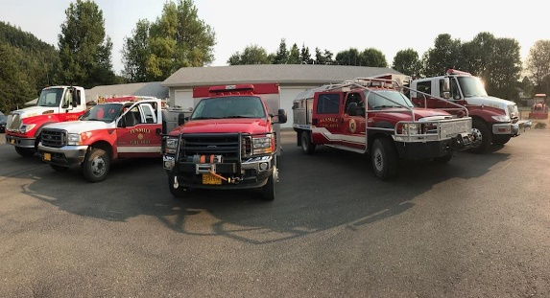
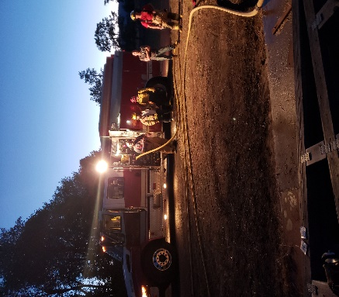
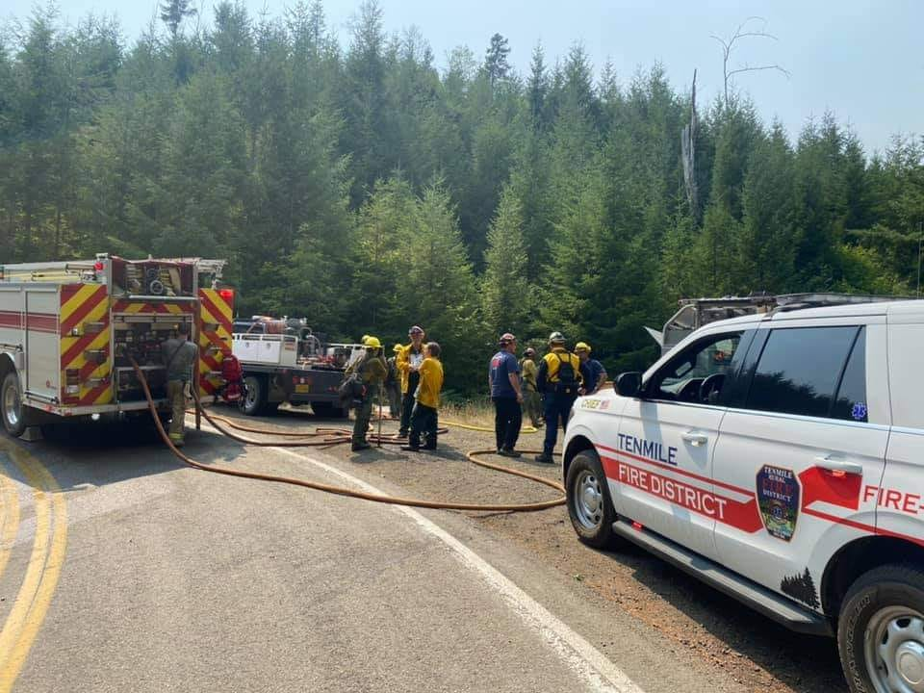
Start Work Week of January 15th, 2023

